Ukulele Songbook

Vol 6

1. I Will Be The One – The Quiet American

3. Baby, It’s Cold Outside - ??

5. Paper Bag - Fiona Apple

6. Moon River – Andy Williams

7. Friday I’m In Love – The Cure

9. You Belong To Me – King/Price/Stewart

11. Trapeze Swinger – Iron and Wine

15. Everybody Wants To Rule The World – Tears For Fears

17. Don’t Stop Believing – Journey

19. On The Road Again – Willie Nelson

21. King Of Spain – Moxy Früvous

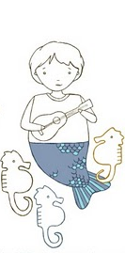23. Splatter Splatter – Moxy Früvous

25. Come Fly With Me – Frank Sinatra

27. Kokomo – The Beach Boys

29. Big Rock Candy Mountain – Burl Ives

31. Love Song - Sara Bareilles

v 1.1

**I Will Be The One – The Quiet American**

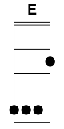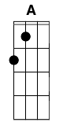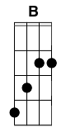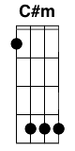 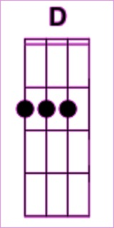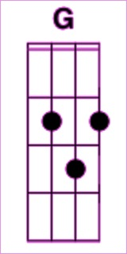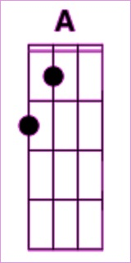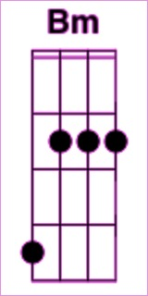

**Capo 3**

**ED**

I slept outside the other night

**AG ED**

cause I could not find the key

**BA**

I woke up with the dew upon my head

**C#mBm BA AG ED**

But I will be the one who sleeps outside for fun

**BA ED**

Cause I don’t mind the dew upon my head

**C#mBm BA AG ED**

**BA ED**

I don’t mind the dew upon my head

**ED**

I walked a mile the other day

**AG ED**

Cause I didn’t have the gas

**BA**

I wore the toe and heel right out my boot

**C#mBm BA AG ED**

But I will be the one who walks a mile for fun

**BA ED**

Cause I don’t mind the rocks under my feet

**C#mBm BA AG ED**

Oooooooooooooh

**BA ED**

I don’t mind the rocks under my feet

**ED**

And I broke my word one time last year

**AG ED**

To the man who can’t say no

**BA**

I walked away and I left him sitting still

**C#mBm BA AG ED**

But I will be the one who hangs his head for fun

**BA ED**

Cause I don’t mind the cost of being wrong

**C#mBm BA AG ED**

Oooooooooooooh

**BA ED**

I don’t mind the cost of being wrong

*Solo – finger pick the chords*

**ED**

Well I dug a grave the other night

**AG ED**

Cause I just lost a friend

**BA**

I tore my hands and I ripped the sod apart

**C#mBm BA AG ED**

But I will be the one who digs a grave for fun

**BA ED**

Cause I don’t mind the taste of giving up

**C#mBm BA AG ED**

Oooooooooooooh

**BA ED**

I don’t mind the taste of giving up

**ED**

But I made a wish when I woke today

**AG ED**

Cause I just can’t look back

**BA**

I closed my eyes and I sent it on its way

**C#mBm BA AG ED**

Oh but I will be the one who makes a wish for fun

**BA ED**

Cause I don’t mind giving my wishes away

**C#mBm BA AG ED**

Oooooooooooooh

**BA ED**

I don’t mind giving my wishes away

**BA ED**

I don’t mind giving my wishes away

*Ending flourish*

**Baby, It’s Cold Outside - ??**

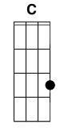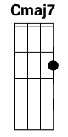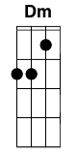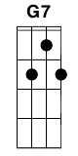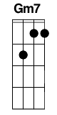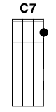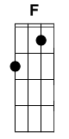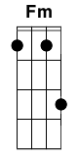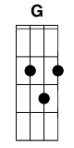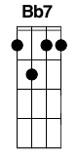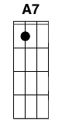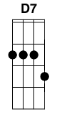

**C  Cmaj7  C  Cmaj7**I really can't stay  
But baby it's cold outside  
  
**Dm  G7  Dm  G7**  
I've got to go away  
But baby it's cold outside  
  
**C  Cmaj7  C  C**  
This evening has been  
Been hoping that you'd drop in  
  
**Gm7  Gm7  C7  C7**So very nice  
I'll hold your hands, they're just like ice  
  
**F  F  F  F**  
My mother will start worry  
Beautiful what’s your hurry?  
  
**Fm  Fm  Fm  Fm**And father will be pacing the floor  
Listen to the fireplace roar  
  
**C  C  C  C**  
So really I'd better scurry  
Beautiful please don't hurry  
  
**Dm  Dm  G  G**Well, maybe just a half a drink more  
Put some records on while I pour  
  
**C  Cmaj7  C  Cmaj7**The neighbors might think  
Baby it's bad out there  
  
**Dm  G7  Dm  G7**  
Say, what's in this drink?  
No cabs to be had out there  
  
**C  Cmaj7  C  C**  
I wish I knew how  
Your eyes are like starlight now  
  
**Gm7  Gm7  C7  C7**  
To break the spell  
I'll take your hat, your hair looks swell  
  
**F  F  F  F**I ought to say, "No, no, no sir"  
Mind if I move in closer  
  
**Fm  Fm  G7  G7**  
At least I'm gonna say that I tried  
What's the sense in hurtin' my pride?  
  
**C  Bb7  A7  A7**I really can't stay  
Baby don't hold out  
  
**D7  G7  C  C**  
Ah, but it's cold outside

**Paper Bag - Fiona Apple**

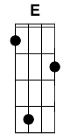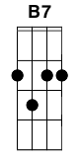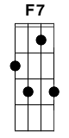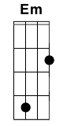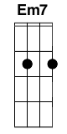  
**E             C         G            B7**  
I was staring at the sky, just looking for a star  
**E           C           G            B7**  
To pray on, or wish on, or something like that  
**E             C           G          B7**I was having a sweet fix of a daydream of a boy  
**F7      Em          A7**  
Whose reality I knew, was a hopeless to be had  
**E       C              G       B7**

But then the dove of hope began its downward slope  
**E                        C**  
And I believed for a moment that my chances  
**G               B7**Were approaching to be grabbed  
**E         C              G    F7**  
But as it came down near, so did a weary tear  
**Em            A7 F7**I thought it was a bird, but it was just a paper bag

***Chorus:***  
**G         Cmaj7 F7       G**  
Hunger hurts, and I want him so bad, oh it kills  
**G          Cmaj7        F7**'Cause I know I'm a mess he don't wanna clean up  
**G                 Cmaj7        F7      G**  
I got to fold 'cause these hands are too shaky to hold  
**Em7                 A7             F7                G B7**  
Hunger hurts, but starving works, when it costs too much to love

**E          C      G**  
And I went crazy again today,  
**B7            E                C             G           B7   E**  
looking for a strand to climb, looking for a little hope  
**C                G              B7              F7**  
Baby said he couldn't stay, wouldn't put his lips to mine  
**Em                A7**And a fail to kiss is a fail to cope  
**E             C       G                 B7**  
I said, 'Honey, I don't feel so good, don't feel justified  
**E           C           G          B7**  
Come on put a little love here in my void,'   
 **E           C** **G                        F7**  
He said 'It's all in your head,' and I said, 'So's everything' but he didn't get it  
**Em A7**I thought he was a man  
**F7**  
But he was just a little boy  
  
***Repeat Chorus 2x***

***Outro:* G Cmaj7 F7 G / G Cmaj7 F7 F7**

**G Cmaj7 F7 G / Em7 A7 F7 F7 / F7 F7 G**

**Moon River – Andy Williams**

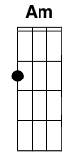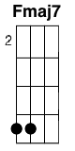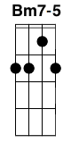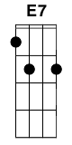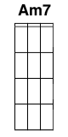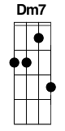

**C Am Fmaj7 C**

Moon River, wider than a mile

**Fmaj7 C Bm7-5 E7**

I'm crossing you in style some day

**Am C7**

You dream maker

**F Fm**

You heartbreaker

**Am7 D7**

Wherever you're going

**Dm7 G7**

I'm going your way

**C Am Fmaj7 C**

Two drifters off to see the world

**Fmaj7 C Bm7-5 E7**

There's such a lot of world to see

**Am Am7 D7 Fm C**

We're after the same rainbow's end

**F C**

Waitin' round the bend

**F C**

My Huckleberry friend

**Am Dm7 G7 C**

Moon River and me

**Friday I’m In Love – The Cure**

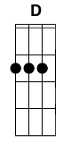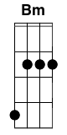

**D               G**I don't care if Monday's blue  
**D                  A**Tuesday's grey and Wednesday too  
**Bmin             G**  
Thursday I don't care about you  
**D             A**It's Friday I'm in love  
  
**D              G**   
Monday you can fall apart  
**D                 A**Tuesday Wednesday break my heart  
**Bmin             G**  
Thursday doesn't even start  
**D             A**   
It's Friday I'm in love  
  
**G        A**  
Saturday wait  
**Bmin              G**And Sunday always comes too late  
   **D            A**   
But Friday never hesitate...  
  
**D               G**  
I don't care if Mondays black  
**D                 A**   
Tuesday Wednesday heart attack  
**Bmin           G**Thursday never looking back  
**D             A**   
It's Friday I'm in love  
  
(**D,G,D,A,Bmin,G,D,A**)...  
  
**D              G**   
Monday you can hold your head  
**D                 A**  
Tuesday Wednesday stay in bed  
  **Bmin               G**   
Or Thursday watch the walls instead  
**D                  A**   
It's Friday I'm in love  
  
**G        A**  
Saturday wait  
**Bmin              G**And Sunday always comes too late  
**D            A**   
But Friday never hesitate...

**Bmin              G**Dressed up to the eyes, it's a wonderful surprise  
**D            A**To see your shoes and your spirits rise  
**Bmin              G**Throwing out your frown and just smiling at the sound  
**D                 A**   
And as sleek as a shriek spinning round and round  
**Bmin              G**Always take a big bite, it's such a gorgeous sight  
**D          A**To see you eat in the middle of the night  
**Bmin              G**You can never get enough, enough of this stuff  
**D           A**It's Friday I'm in love  
  
**D               G**I don't care if Monday's blue  
**D                  A**   
Tuesday's grey and Wednesday too  
**Bmin             G**Thursday I don't care about you  
**D             A**   
It's Friday I'm in love  
  
**D              G**   
Monday you can fall apart  
**D                 A**  
Tuesday Wednesday break my heart  
**Bmin             G**  
Thursday doesn't even start  
**D             A**   
It's Friday I'm in love  
  
(**D,G,D,A,Bmin,G,D,A**)...**You Belong To Me - King/Price/Stewart**

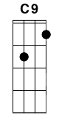****

Intro: **C C9 Em7 F C F Fm C Em7 Am7 Dm7 G C**

**C Em7**

See the pyramids along the Nile

**F C**

Watch the sunrise from a tropic isle

**F Fm C Em7 Am7**

Just remember darling all the while

**Dm7 G G7**

You belong to me

**C Em7**

See the market place in old Algiers

**F C**

Send me photographs and souvenirs

**F Fm C Em7 Am7**

Just remember when a dream appears

**Dm G7 G**

You belong to me

**C F**

I'd be so alone without you

**Dm7 Fmaj7 G**

Maybe you'll be lonesome too

**G7**

and blue

**C Em7**

Fly the ocean in a silver plane

**F C**

See the jungle when it's wet with rain

**F Fm C Em7 Am7**

Just remember till you're home again

**Dm G C**

You belong to me

***Repeat Intro***

**C F**

I'd be so alone without you

**Dm7 Fmaj7 G**

Maybe you'll be lonesome too

**G7**

and blue

**C Em7**

Fly the ocean in a silver plane

**F C**

See the jungle when it's wet with rain

**F Fm C Em7 Am7**

Just remember till you're home again

**Dm G C**

You belong to me

**Trapeze Swinger – Iron and Wine**

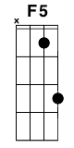

**C** **G**

Please, remember me

**F5**

Happily

**C G**

By the rosebush laughing

**C G**

With bruises on my chin

**F5**

The time when

**C G**

We counted every black car passing

**Am G**

Your house beneath the hill

**F5**

And up until

**C G**

Someone caught us in the kitchen

**Am G**

With maps, a mountain range

**F5**

A piggy bank

**C G**

A vision too removed to mention

And

**C** **G**

Please, remember me

**F5**

Fondly

**C** **G**

I heard from someone you're still pretty

**C** **G**

And then they went on to say

**F5**

That the pearly gates

**C** **G**

Had such eloquent graffiti

**Am** **G**

Like "We'll meet again"

**F5**

And "Fuck the man"

**C** **G**

And "Tell my mother not to worry"

**Am** **G**

And angels with their great

**F5**

Handshakes

**C** **G**

Were always done in such a hurry

And

**C** **G**

Please, remember me

**F5**

That Halloween

**C** **G**

Making fools of all the neighbors

**C** **G**

Our faces painted white

**F5**

By midnight

**C** **G**

We'd forgotten one another

**Am** **G**

And when the morning came

**F5**

I was ashamed

**C** **G**

Only now it seems so silly

**Am** **G**

That season left the world

**F5**

And then returned

**C** **G**

And now you're lit up by the city

And

**C** **G**

Please, remember me

**F5**

Mistakenly

**C** **G**

In the window of the tallest tower

**C** **G**

Calling passers-by

**F5**

We're much too high

**C** **G**

To see the empty road at happy hour

**Am** **G**

Gleam and resonate

**F5**

Just like the gates

**C** **G**

Around the holy kingdom

**Am** **G**

With words like "Lost and found"

**F5**

And "Don't look down"

**C** **G**

And "Someone save Temptation"

And

 **C** **G**

Please, remember me

**F5**

As in the dream

**C** **G**

We had as rug-burn babies

**C** **G**

Among the fallen trees

**F5**

We're fast asleep

**C** **G**

Beside the lions and the ladies

**Am** **G**

That called you what you like

**F5**

And even might

**C** **G**

Give a gift for your behavior

**Am** **G**

A fleeting chance to see

**F5**

A trapeze

**C** **G**

Swinger high as any savior

And

**C** **G**

Please, remember me

**F5**

My misery

**C** **G**

And how it lost me all I wanted

**C** **G**

Those dogs that love the rain

**F5**

And chasing trains

**C** **G**

The colored birds above their running

**Am** **G**

In circles around the well

**F5**

And where it spells

**C** **G**

On the wall behind St. Peter

**Am** **G**

So bright on cinder gray

**F5**

In spray paint

**C** **G**

"Who the hell can see forever?"

And

**C** **G**

Please, remember me

**F5**

Seldomly

**C** **G**

In the car behind the carnival

**C** **G**

My hand between your knees

**F5**

You turned from me

**C** **G**

And said, "The trapeze act was wonderful

**Am** **G**

But never meant to last"

**F5**

The clowns that passed

**C** **G**

Saw me just come up with anger

**Am** **G**

When it filled with circus dogs

**F5**

The parking lot

**C** **G**

Had an element of danger

And

**C** **G**

Please, remember me

**F5**

Finally

**C** **G**

And all my uphill clawing

**C** **G**

My dear, but if I make

**F5**

The pearly gates

**C** **G**

I'll do my best to make a drawing

**Am** **G**

Of God and Lucifer

**F5**

A boy and girl

**C** **G**

An angel kissing on a sinner

**Am** **G**

A monkey and a man

**F5**

A marching band

**C** **G**

All around the frightened trapeze swinger

**C** **G**

Na, na-na

**F5**

Na-na

**C** **G**

Na-na, na-na

**C** **G**

Na-na-na, na-na

**F5**

Na-na

**C** **G**

Na-na-na, na-na

**C**

Na-na-na

**Everybody Wants To Rule The World – Tears For Fears**

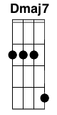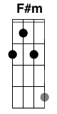

***Intro:***

**Dmaj7** **G** | **Dmaj7** **G** | **Dmaj7** **G** | **Dmaj7** **G** | **Dmaj7** **G**

***Verse 1:***

(**G**) **Dmaj7** **G**

Welcome to your life,

**Dmaj7** **G**

There's no turning back,

**Dmaj7** **G**

Even while we sleep,

We will find you,

***Chorus 1:***

**Em** **F#m**

Acting on your best behaviour,

**G** **F#m**

Turn your back on mother nature,

**Em** **F#m** **G** **A** **Dmaj7** **G**

Everybody wants to rule the world

**Dmaj7** **G** | **Dmaj7** **G**

***Verse 2:***

(**G**) **Dmaj7** **G**

It's my own design,

**Dmaj7** **G**

It's my own remorse,

**Dmaj7** **G**

Help me to decide,

Help me make the...

***Chorus 2:***

**Em** **F#m**

...most of freedom and of pleasure,

**G** **F#m**

Nothing ever lasts for ever

**Em** **F#m** **G** **A** (**G**)

Everybody wants rule the world

***Bridge 1:***

**G** **Dmaj7** **A** **G**

There's a room where the light won't find you,

**Dmaj7** **A** **G**

Holding hands while the walls come tumbling down,

**Dmaj7** **A**

When they do I'll be right behind you.

***Chorus 3:***

**Em** **F#m**

So glad we've almost made it,

**G** **F#m**

So sad they had to fade it,

**Em** **F#m** **G** A

Everybody wants to rule the world.

***Solo:*** **Dmaj7** **G** | **Dmaj7** **G** **5x**

***Chorus 4:***

**Em** **F#m**

I can't stand this indecision,

**G** **F#m**

Married with a lack of vision,

**Em** **F#m** **G** **A** (**G**)

Everybody wants to rule the world.

***Chorus 5:***

**G** **F#m**

Say that you'll never never never never need it,

**G** **F#m**

One headline why believe it?,

**Em** **F#m** **G** **A**

Everybody wants to rule the world.

***Solo 2:*** **Dmaj7** **G** | **Dmaj7** **G** 5x

***Chorus 6:***

**Em** **F#m**

All for freedom and for pleasure,

**G** **F#m**

Nothing ever lasts for ever,

**Em** **F#m** **G** **A** **Dmaj7** **G**

Everybody wants to rule the world

***Outro:*** **Dmaj7** **G** | **Dmaj7** **G** to fade (or end on **G**)

**Don’t Stop Believing – Journey**



*Chord Progressions: I-V-vi-IV; I-V-iii-IV; iii-IV-I; iii-IV-V*

**Capo 4**

**Intro: C G Am F C G Am F**

***Verse 1:***

**C** **G** **Am** **F**

Just a small town girl, living in a lonely world

**C** **G** **Em** **F**

She took the midnight train going anywhere

***Verse 2:***

**C** **G** **Am** **F**

Just a city boy, born and raised in south Detroit

**C** **G** **Em** **F**

He took the midnight train going anywhere

***Interlude:***

**C** - **G** - **Am** - **F** x2

***Verse 3:***

**C** **G** **Am** **F**

A singer in a smoky room, a smell of wine and cheap perfume

**C** **G** **Em** **F**

For a smile they can share the night, it goes on and on and on and on

***Chorus:***

**~~G~~****~~F~~****~~G~~****~~Am~~****~~F~~** ~~-~~ **~~G~~****~~F~~****~~G~~**

**Em7 F C**

Strangers waiting up and down the boulevard

**~~G~~****~~F~~****~~G~~****~~Am~~****~~F~~****~~G~~****~~F~~** ~~-~~ **~~G~~**

**Em7 F C**

Their shadows searching in the night

**~~G~~****~~F~~****~~G~~****~~Am~~****~~F~~** ~~-~~ **~~G~~****~~F~~****~~G~~**

**Em7 F C**

Streetlight, people, living just to find emotion

**~~G F G Am G~~**

**Em7 F G**

Hiding, somewhere in the night

***Verse 4:***

**C** **G** **Am** **F**

Working hard to get my fill, everybody wants a thrill

**C** **G** **Em** **F**

Paying anything to roll the dice, just one more time

***Verse 5:***

**C** **G** **Am** **F**

Some will win, some will lose, some were born to sing the blues

**C** **G** **Em** **F**

Oh, the movie never ends; it goes on and on and on and on

***Chorus:***

**~~G~~****~~F~~****~~G~~****~~Am~~****~~F~~** ~~-~~ **~~G~~****~~F~~****~~G~~**

**Em7 F C**

Strangers waiting up and down the boulevard

**~~G~~****~~F~~****~~G~~****~~Am~~****~~F~~****~~G~~****~~F~~** ~~-~~ **~~G~~**

**Em7 F C**

Their shadows searching in the night

**~~G~~****~~F~~****~~G~~****~~Am~~****~~F~~** ~~-~~ **~~G~~****~~F~~****~~G~~**

**Em7 F C**

Streetlight, people, living just to find emotion

**~~G F G Am G~~**

**Em7 F G**

Hiding, somewhere in the night

***Outro:***

**C** **G** **Am** **F**

Don't stop believing hold on to the feeling

**C** **G** **Em** **F**

Streetlight people

**C** **G** **Am** **F**

Don't stop believing hold on to the feeling

**C** **G** **Em** **F**

Streetlight people

**C** **G** **Am** **F**

Don't stop believing hold on to the feeling

**C** **G** **Em** **F**

Streetlight people

**On The Road Again – Willie Nelson**

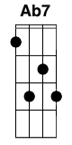 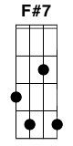

Capo 2

***Intro:*** **ED**

**ED**

On the road again

**Ab7F#7**

Just can't wait to get on the road again

**F#mEm**

The life I love is making music with my friends

**AG** **B7A7** **ED**

And I can't wait to get on the road again

**ED**

On the road again

**Ab7F#7**

Goin' places that I've never been

**F#mEm**

Seein' things that I may never see again

**AG** **B7A7** **ED**

And I can't wait to get on the road again

***Bridge:***

**AG**

On the road again

**ED**

Like a band of gypsies we go down the highway

**AG**

We're the best of friends

**ED** **B7A7**

Insisting that the world keep turning our way and our way

**ED**

Is on the road again

**Ab7F#7**

I just can't wait to get on the road again

**F#mEm**

The life I love is making music with my friends

**AG** **B7A7** **ED**

And I can't wait to get on the road again

**ED** **Ab7F#7** **F#mEm** **AG** **B7A7** **ED** x2

***Bridge:***

**AG**

On the road again

**ED**

Like a band of gypsies we go down the highway

**AG**

We're the best of friends

**ED** **B7A7**

Insisting that the world keep turning our way and our way

**ED**

Is on the road again

**Ab7F#7**

Just can't wait to get on the road again

**F#mEm**

The life I love is making music with my friends

**AG** **B7A7** **ED**

And I can't wait to get on the road again

**AG** **B7A7** **ED**

And I can't wait to get on the road again

***Outro:*** **AG** **B7A7** **ED** x1

**King of Spain – Moxy Früvous**

**C** **F** **C**

Once I was the King of Spain

**C** **F** **C**

now I eat humble pie

**C** **F** **C**

Oh... my unspeakable wife, Queen Lisa

**C** **F** **C**

now I eat humble pie

**C** **F** **C**

I'm telling you I was the King of Spain

**C** **F** **C**

now I eat humble pie

**C** **G** **C**

And now I work at the Pizza Pizza 1 2 3 4!

**C** **F** **C** **F** **C**

**C** **F** **C** **G** **C**

**C** **F**

Royalty, lord it looked good on me

**F** **C** **G** **C**

Buried in silk in the royal boudoir or going nuclear free

**C** **F**

Or playing Crokinole with the Princess of Monaco

**F** **C** **G** **C**

Telling my jokes to the OPEC leaders, getting it all on video

**C** **F** **C**

Once I was the King of Spain

**C** **G** **C**

now I eat humble pie

**C** **F** **C**

A palatial palace, that was my home

**C** **G** **C**

now I eat humble pie

**C** **F** **C**

I'm telling you I was the King of Spain

**C** **G** **C**

now I eat humble pie

**C** **G** **C**

And now I vacuum the turf at SkyDome

**C** **F** **C**

Once he was the King of Spain

**C** **F**

I can't wait, I'm lowering interest rates; my people say:

**F** **C** **G** **C**

"King, how are you such a genius? There's a roof overhead and food on our plates!"

**C** **F**

It's laissez-faire, I don't even give a care

**F** **C** **G** **C**

Let's make Friday part of the weekend and give every new baby a chocolate eclair

**C** **F** **C**

Once I was the King of Spain

**C** **G** **C**

now I eat humble pie

**C** **F** **C**

Hey Clinton! Hey Yeltsin! Got problems? You phone me!

**C** **G** **C**

now I eat humble pie

**C** **F** **C**

I'm telling you I was the King of Spain

**C** **G** **C**

now I eat humble pie

**C** **G** **C**

Now the Leafs call me up to drive the Zamboni

**C** **F** **C**

Once he was the King of Spain

Ladies and Gentlemen, I introduce to you the international orchestra!

***Kazoo:* F** **C** **G** **Am** **F** **C**

**C**

Now some of you might be wondering how I came to be living in Canada

after being royalty in Spain. Should I tell them, guys?

Tell us, King!

**C** **F**

You see late one night when the palace was asleep

**F** **C** **G** **C**

Out of my royal chambers and into the garden I creep

**C** **F**

And I wait till the appointed time, when the moon is lighting the pitch

**F** **C** **G** **C**

At which point my peasant friend, who looks just like me arrives and we make a switch!

**C** **F**

Prince and pauper, junior and whopper, world made up of silver and copper

**F** **C** **G**

Under my own volition, I took a change of position

**C** **F**

So next time you drool in the pizza line

**F** **C**

Remember, slower pizza's more luscious: the King of Spain never rushes!

**C** **F** **C**

Once I was the King of Spain

**C** **G** **C**

now I eat humble pie

**C** **F** **C**

I was looking for offhanded ways to improve us

**C** **G** **C**

now I eat humble pie

**C** **F** **C**

I'm telling you I was the King of Spain

**C** **G** **C**

now I eat humble pie

**C** **G** **C**

And now I'm jamming with Moxy Fruvous!

**C** **F** **C**

Once he was the King of Spain

**Splatter Splatter – Moxy Früvous**

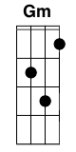 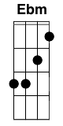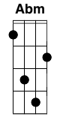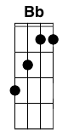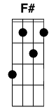

Intro:

Dm Dm

A---------------------5-5----- A--------------------5-7---

E-----1---------------3-5----- E----1---------------3-----

C---2------------------------- D--2-----------------------

G-------2-4--4-5-4-3---------- G------2-4--4-5-4-3--------

**Dm**

Kids in their PJs. Big bowl of nachos

**Gm** **A** **Dm**

Another perfect day in Rhodedendron Park.

**Dm**

The sun is shining. Now dad's reclining

**Gm** **A** **Dm**

Roll down the blinds to watch a movie in the dark.

**Dm**

Some buxom ladies. A Lambourghini

**Gm** **A** **Dm**

Shadowy motives in a shadowy land.

**Dm**

Some idle chatter, then Splatter Splatter

**Gm** **A** **Dm**

Cue soundtrack music from the up-and-coming band.

**F** **A** **Dm**

This is the best I've ever seen

**Gm**

(She's just a teen...)

**Gm**

I want to see it

**Bbm** **Dm**

Again and again and again

**Dm**

She's babysitting and doing homework.

**Gm** **A** **Dm**  
**A** sudden phone call from the senior quarterback.

**Dm**  
She loves attention, she craves attention

**Gm** **A** **Dm**  
He's got a present for her from her daddy's shack

**Dm**

She getting cozy The window rattles

**Gm** **A** **Dm**  
**A** few allusions to last summer's episode.

**Dm**  
The windows shatter then Splatter splatter

**Gm** **A** **Dm**

What could be more perfect than to see her head explode?

**F** **A** **Dm**

This is the best I've ever seen

**Gm**

(She's just a teen...)

**Gm**

I want to see it

**Bbm** **Dm**

Again and again and again

***(key change #)***

**Ebm**  
We came from monkeys, we once were hunted

**Abm** **Bb** **Ebm**  
Perhaps we recognize that hunted human face

**Ebm**  
Maybe the suburbs are just far too antiseptic

**Abm** **Bb** **Ebm**  
Kids need some splatter splatter messing up the place.

**F#** **Bb** **Ebm**

This is the best I've ever seen

**Abm**

(She's just a teen...)

**Abm**

I want to see it

**Bm** **Ebm**

Again and again and again and again  
Again and again and again  
  
**F#** **Bb** **Ebm**

This is the best I've ever seen

**Abm**

(She's just a teen...)

**Abm**

I want to see it

**Bm** **Ebm**

Again and again and again

**Bm Ebm**

Again and again and again

**Bm Ebm**

Again and again and again

**Come Fly With Me – Frank Sinatra**

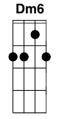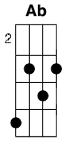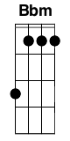****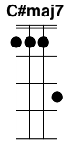

**Verse 1:**

**(G7) C C9 Dm Dm7 Dm6**

Come fly with me! Let's fly, let's fly away!

**C Am C7**

If you can use some exotic booze,

**F Fm**

There's a bar in far Bombay,

**CMaj7 Am Dm7 G7 E7 Dm7 G7**

Come fly with me, let's fly, let's fly away.

**(G7) C C9 Dm Dm7 Dm6**

Come fly with me! Let's float down to Peru.

**C Am C7**

In llama land, there's a one-man band

**F Fm**

And he'll toot his flute for you.

**CMaj7 Am Dm7 G7 C**

Come fly with me! Let's take off in the blue.

**Bridge:**

**Ab Bbm**

Once I get you up there, where the air is rarified,

**Ab**

We'll just glide, starry-eyed.

**Ab G**

Once I get you up there, I'll be holding you so near

**G D7**

You may hear the angels cheer

**G7**

Because we're together,

**Verse 2:**

**C C9 Dm Dm7 Dm6**

Weather-wise, it's such a lovely day!

**(G7) CMaj7 C7**

Just say the words and we'll beat the birds

**F Fm**

Down to Acapulco Bay;

**CMaj7 Gm A7**

It's perfect for a flying honey-moon, they say.

**D7 G7 C Am7 Dm7 G7**

Come fly with me! Come fly, let's fly away. (Oh, let’s fly!)

(**SOLO**)

**(REPEAT BRIDGE)**

**(REPEAT VERSE 2)**

**CODA:**

**D9 D7 G7 C**

Come fly with me! Let's fly, let's fly… pack up let’s fly a-way.

**C – C7 – F – Fm – G – C#Maj7 – CMaj7**

**Kokomo – The Beach Boys**



**C**

Aruba, Jamaica, ooh I wanna take ya

**F**

Bermuda, Bahama, come on pretty mama

**C F**

Key Largo, Montego, baby why don't we go, Jamaica

**C Cmaj7**

Off the Florida Keys

**Gm7 F**

There's a place called Kokomo

**Fm C D7 G7**

That's where you wanna go to get away from it all

**C Cmaj7**

Bodies in the sand

**Gm7 F**

Tropical drink melting in your hand

**Fm C D7 G7**

We'll be falling in love to the rhythm of a steel drum band

**C**

Down in Kokomo

**Chorus:**

**C**

Aruba, Jamaica, ooh I wanna take ya to

**F**

Bermuda, Bahama, come on pretty mama

**C F**

Key Largo Montego, ooh I wanna take her down to Kokomo

**Fm C**

We'll get there fast and then we'll take it slow

**Am D7**

That's where we wanna go

**G7 C**

Way down in Kokomo

**C**

Martinique, that Montserrat mystique

**C Cmaj7**

We'll put out to sea

**Gm7 F**

And we'll perfect our chemistry

**Fm C D7 G7**

By and by we'll defy a little bit of gravity

**C Cmaj7**

Afternoon delight

**Gm7 F**

Cocktails and moonlit nights

**Fm C D7 G7**

That dreamy look in your eye give me a tropical contact high

**C**

Way down in Kokomo

***Chorus***

**C**

Port Au Prince, I wanna catch a glimpse

Sax Solo: **C Gm7 F Fm C D7 G7**

**C Cmaj7**

Everybody knows

**Gm7 F**

A little place like Kokomo

**Fm C D7 G7**

Now if you wanna go and get away from it all

**C**

Go down to Kokomo

***Chorus x2***

**Big Rock Candy Mountain – Burl Ives**



**C G C**

One evening as the sun went down and the jungle fires were burning

**C G C**

Down the track came a hobo hiking and he said, "Boys I'm not turning" I'm

**F C F C F C G**

headed for a land that's far away besides the crystal fountain So

**C G C**

come with me we'll go and see the Big Rock Candy Mountain

**C F C**

In the Big Rock Candy Mountain There's a land that's fair and bright the

**F C F G**

handouts grow on bushes and you sleep out every night Where the

**C F C**

boxcars all are empty and the sun shines every day On the

**F C F C F C**

birds and the bees the cigarette trees the lemonade springs where the

**F C G C**

bluebird sings in The Big Rock Candy Mountain

**C F C**

In The Big Rock Candy Mountain all the cops have wooden legs and the

**F C F G**

bulldogs all have rubber teeth and the hens lay soft boiled eggs The

**C F C**

farmer's trees are full of fruit and the barns are full of hay Oh I'm

**F C F C F C**

bound to go where there ain't no snow where there ain't no fall and the

**F C G C**

winds don't blow in The Big Rock Candy Mountain

**C F C**

In The Big Rock Candy Mountain you never change your socks and the

**F C F G**

little streams of alcohol come a tricklin' down the rocks The

**C F C**

brakemen have to tip their hats and the railroad bulls are blind There's a

**F C F C F C**

lake of stew and of whiskey too you can paddle all around them in a

**F C G C**

big canoe in The Big Rock Candy Mountain

**C F C**

In The Big Rock Candy Mountain the jails are made of tin and

**F C F G**

you can walk right out again as soon as you are in There

**C F C**

ain't no short handle shovels no axes saws or picks I'm

**F C F C**

gonna stay where you sleep all day where they

**F C F C**

hung the jerk that invented work in The

**G C C F C F**

Big Rock Candy Mountain .....

**C F C F C G C**

I'll see you all this comin fall in the Big Rock Candy Mountain

**Love Song – Sara Bareilles**

Verse 1

Gm Bb

head under water

Dm

and they tell me

F

to breathe easy for a while

Gm Bb

but breathing gets harder

Dm F

even i know that

Gm Bb

you made room for me

Dm

but its too soon to see

F

if im happy in your hands

Gm Bb Dm F

im unusually hard to hold on to

Prechorus:

Gm Am

blank stares at blank pages

Bb Am

no easy way to say this

Gm Am Bb

you mean well, but you make this hard on me

Chorus:

Gm

i'm not gonna write you a love song

C

'cause you asked for it

F Bb

'cause you need one, you see

Gm

i'm not gonna write you a love song

C

'cause you tell me it's

F

make or break in this

Bb

if you're on your way

Gm F

i'm not gonna write you to stay

Dm G/B

if all you have is leavin' im'a need a better reason

Bb C Gm Bb Dm F

to write you a love song today

Verse 2 (Same as verse 1)

i learned the hard way

that they all say

things you wanna hear

and my heavy heart

sings deep down under you

and your twisted words

your help just hurts

you were not what i thought you were

hello to high and dry

Prechorus:

convinced me to please you

made me think that i need this too

i'm trying to let you hear me as i am

Chorus

i'm not gonna write you a love song

'cause you asked for it

'cause you need one, you see

i'm not gonna write you a love song

'cause you tell me it's

make or break in this

if your on your way

i'm not gonna write you to stay

if all you have is leavin' im'a need a better reason

to write you a love song today

Bridge:

Dm Am Bb

promise me

F C

you'll leave the light on

Dm Am Bb

to help me see

F C

with daylight, my guide, gone

Dm A(maj) Bb

'cause i believe there's a way

C

you can love me because i say

Chorus:

i wont write you a love song

'cause you asked for it

'cause you need one you see

i'm not gonna write you a love song

'cause you tell me it's make or break in this

is that why you wanted a love song

'cause you asked for it

'cause you need one you see

im not gonna write you a love song

'cause you tell me it's make or break in this

if your on your way

im not gonna write you to stay

Dm

if your heart is no where in it

C

i dont want it for a minute

Dm

babe ill walk the seven seas

G/B

when i believe that there's a reason

Bb C Gm Bb Dm F

to write you a love song today, today

**Aerosmith – Crazy**

Come 'ere baby

A F#m D

You know you drive me up a wall the way you make good of all the nasty

Dm

tricks you pull. Seems like we're makin' up more than we're makin'

A F#m

love and it always seems you got somn' on your mind other than me

D Dm

Girl, you got to change your crazy ways, you hear me

A D F#m

Say you're leavin' on a seven thirty train and that you're headin' out

D

to Hollywood

A D F#m

Girl you been givin' me that line so many times it kinda gets like

D

feelin' bad looks good, yeah

E F#m G D

That kinda lovin' turns a man to a slave

E F#m G D E

That kinda lovin' sends a man right to his grave

A F#m D Dm

I go crazy, crazy, baby, I go crazy

A F#m Dm E

You turn it on, then you're gone, yeah, you drive me

A F#m D Dm

Crazy, crazy, crazy for you baby

Bm E C#m F#m E D Dm

What can I do, honey, I feel like the color blue

A D F#m

You're packin' up your stuff and talkin' like it's tough and tryin' to

D

tell me that it's time to go, yeah

A D F#m

But I know you ain't wearin' nothin' underneath that overcoat

D

And it's all a show, yeah

E F#m G D

That kinda lovin' makes me wanna pull down the shade, yeah

E F#m G

That kinda lovin' yeah now I'm never, never, never, never

D E

gonna be the same

A F#m D Dm

I go crazy, crazy, baby, I go crazy

A F#m D E

You turn it on, then you're gone, yeah, you drive me

A F#m D Dm

Crazy, crazy, crazy for you baby

Bm E C#m F#m E D Dm

What can I do, honey, I feel like the color blue

A F#m D E

I'm losin' my mind, girl, 'cause I'm goin' crazy

A F#m D Dm

A F#m D E

A F#m D Dm

A F#m D E

F#m E D

I need your love, honey yeah

F#m E D

I need your love

A F#m D Dm

Crazy, crazy, crazy for you baby

A F#m D E

I'm losin' my mind, girl 'cause I'm goin' crazy

A F#m D Dm

Crazy, crazy, crazy for you baby

A F#m D E

You turn it on, then you're gone, yeah, you drive me

A F#m D Dm

A F#m D E

A F#m D Dm

A F#m D E...

**Huey Lewis And The News – The Power Of Love**

intro C C/E | F G | C C/E | F G |

Cm7 | F | Cm7 | F Bb F |

Cm7 Bb Cm7 **(or Ab7 or F)**

The power of love is a curious thing

Bb Cm7

make a one man weep, make another man sing

Bb Cm7

Change a hawk to a little white dove

Bb Cm7

more than a feeling that's the power of love

| F Gm7 |

Tougher than diamonds, bricks like cream

Stronger and harder than a bad girl's dream

make a bad one good make a wrong one right

power of love that keeps you home at night

Chorus 1 :

C C/E F G

You don't need money, don't take fame

C C/E F G

Don't need no credit card to ride this train

C C/E F G

It's strong and it's sudden and it's cruel sometimes

Bb F Gsus4

but it might just save your life

G Cm7

That's the power of love

F Cm7

That's the power of love

F Bb F

First time you feel it, it might make you sad

Next time you feel it it might make you mad

But you'll be glad baby when you've found

that's the power makes the world go'round

Chorus 2 :

And it don't take money, don't take fame

don't need no credit card to ride this train

It's strong and it's sudden it can be cruel sometimes

but it might just save your life

Eb G7 Cm7

They say that all in love is fair

yeah, but you don't care

Ab Eb/G

But you know what to do

Fm7 Eb

when it gets hold of you

Ab Gsus4

and with a little help from above

G Cm7

you feel the power of love

F Cm7

you feel the power of love

F

Can you feel it ?

Cm7 F Cm7 Bb

Hmmm

Chorus 3 :

It don't take money and it don't take fame

don't need no credit card to ride this train

Tougher than diamonds and stronger than steel

C C/E F G

you won't feel nothin' till you feel

C C/E F Gsus4

you feel the power, just the power of love

C C/E F Gsus4 C

That's the power, that's the power of love

F G

You feel the power of love

C F G C

you feel the power of love

F G C C/E F Gsus4

feel the power of love

C C/E F Gsus4 (to fade)

Chords – GCEA (Standard) Tuning

Maj/Minor

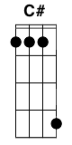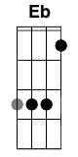

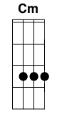

7

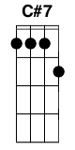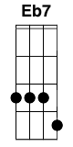

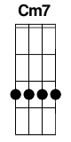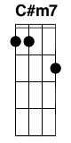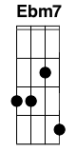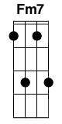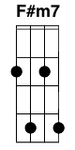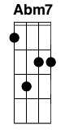****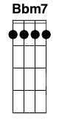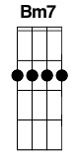

Maj

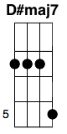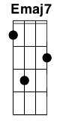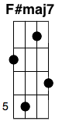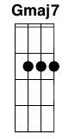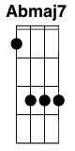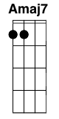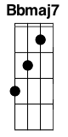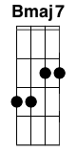

Sus

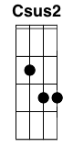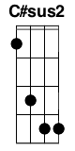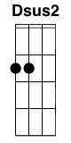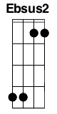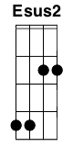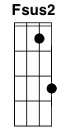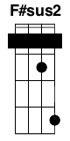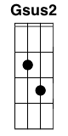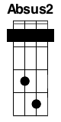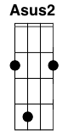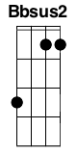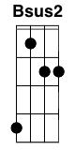

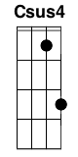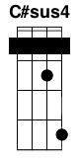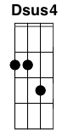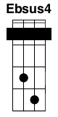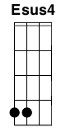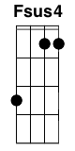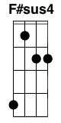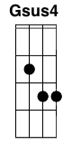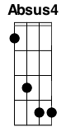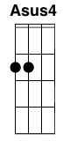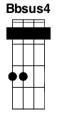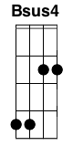

9

 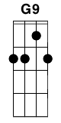 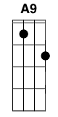

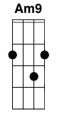

5

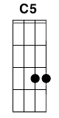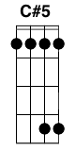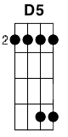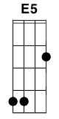 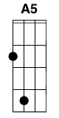 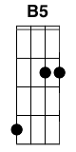

6

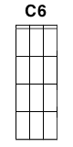 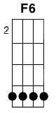 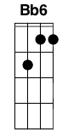

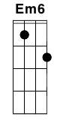 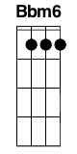

Misc

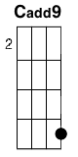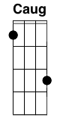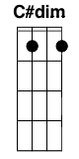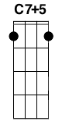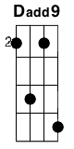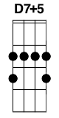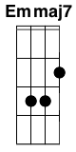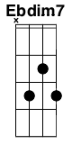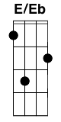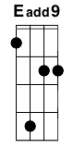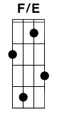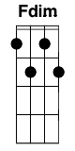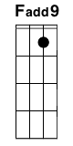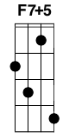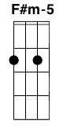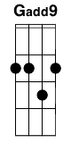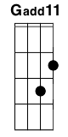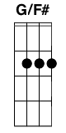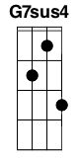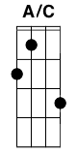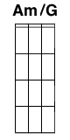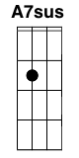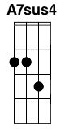

Variations

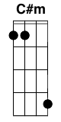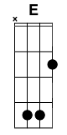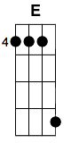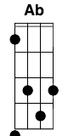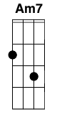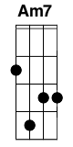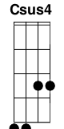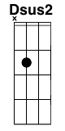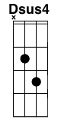

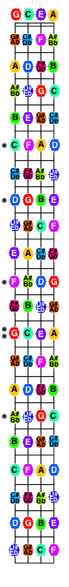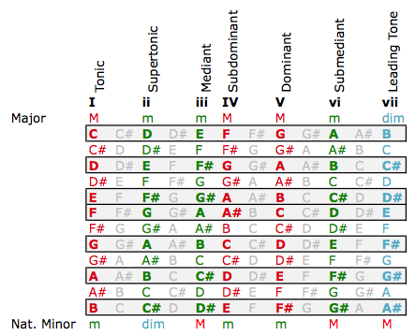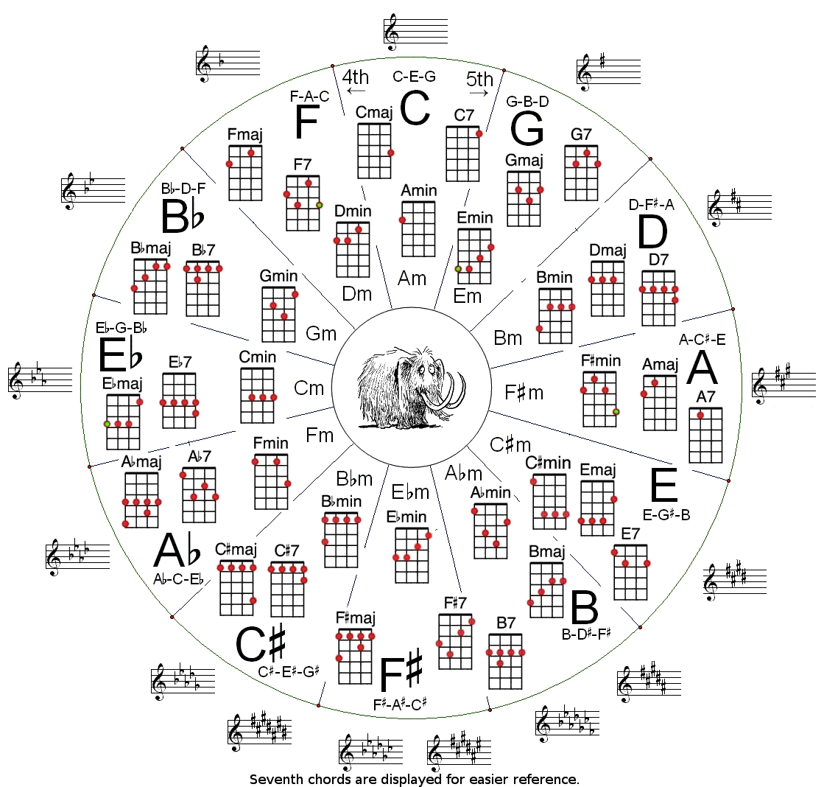

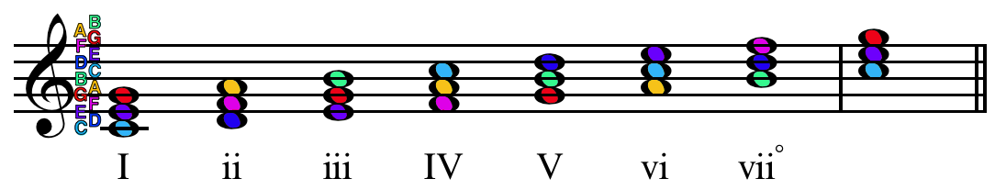

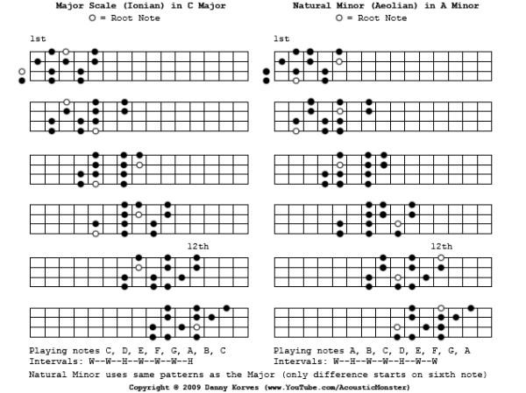

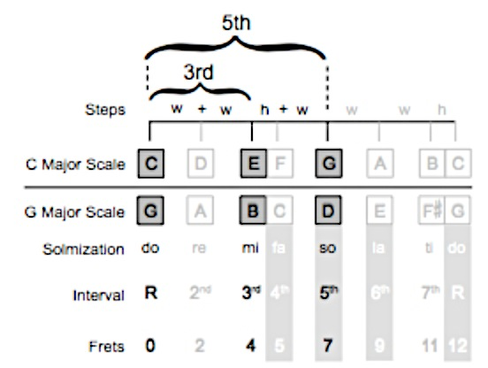

|  |  |
| --- | --- |
| **Chord** | **Leads To** |
| I | Can appear anywhere and lead anywhere |
| ii | I, V, or vii° chords |
| iii | I, IV, or vi chords |
| IV | I, ii, V, or vii° chords |
| V | I, vi chords |
| vi | I, ii, iii, IV, or V chords |
| vii° | I chord |

|  |  |  |  |
| --- | --- | --- | --- |
| Family | Name | Symbol | Formula |
| Major | Major | M, Maj | 1-3-5 |
|  | Added Fourth | add4 | 1-3-4-5 |
|  | Major 7th | Maj7 | 1-3-5-7 |
| Minor | Minor | m | 1-b3-5 |
|  | Minor added fourth | madd4 | 1-b3-4-5 |
|  | Minor sixth | m6 | 1-b3-5-6 |
|  | Minor seventh | m7 | 1-b3-5-b7 |
|  | Minor added ninth | madd9 | 1-b3-5-9 |
|  | Minor/Major seventh | m/Maj7 | 1-b3-5-7 |
|  | Minor seven flat fifth | m7-5 or ø | 1-b3-b5-b7 |
| Dominant | Seventh | 7 | 1-3-5-b7 |
|  | Seven sharp five | 7#5 | 1-3-#5-b7 |
|  | Seven flat five | 7b5 | 1-3-b5-b7 |
| Diminished | Diminished | dim (° ) | 1-b3-b5 |
|  | Diminished Seventh | dim7 (°7) | 1-b3-b5-bb7 |
| Augmented | Augmented | aug (+) | 1-3-#5 |
| Misc | Fifth | 5 | 1-5 |
|  | Flat Fifth | -5 | 1-b5 |
|  | Suspended Fourth | sus4 | 1-4-5 |
|  | Suspended Second | sus2 | 1-2(9)-5 |
|  | Sharp Eleven | #11 | 1-5-#11 |

*Note: Ninth, Eleventh, and Thirteenth chords cannot be played on ukulele.*

**Common 4/4 Strumming Patterns**

D-D-D-D- D-DU-UD-

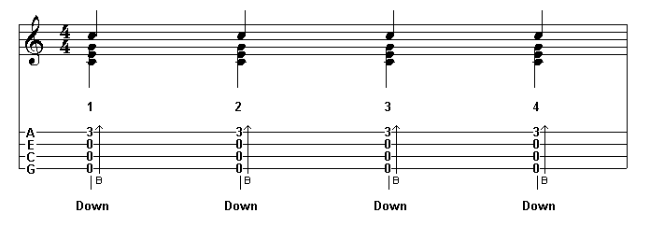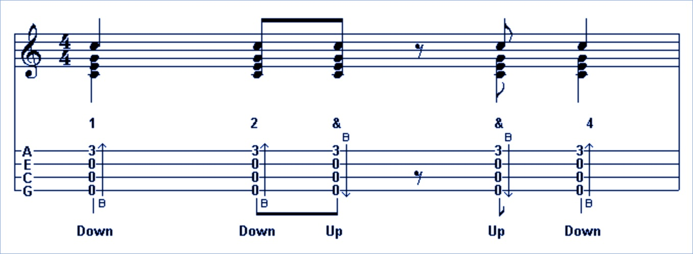

DUDUDUDU D-DU-UDU

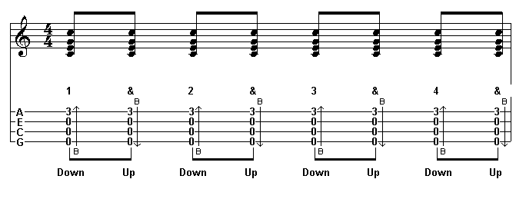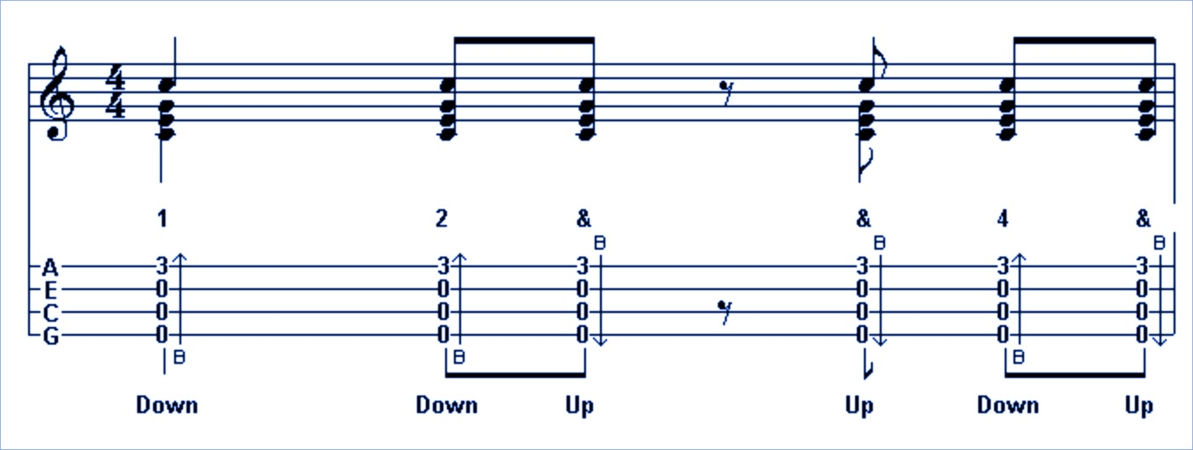

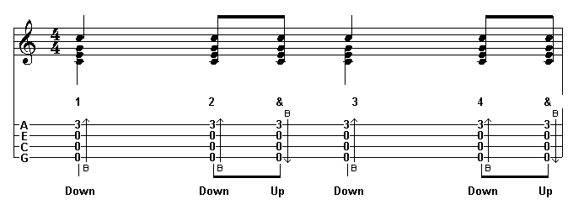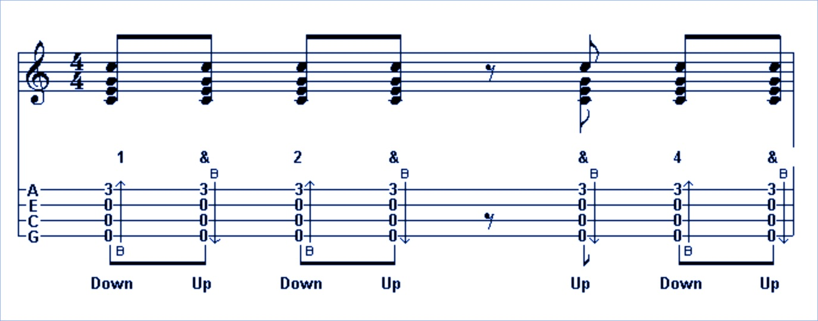D-DUD-DU DUDU-UDU

D-DUDUDU DUxUDUxU

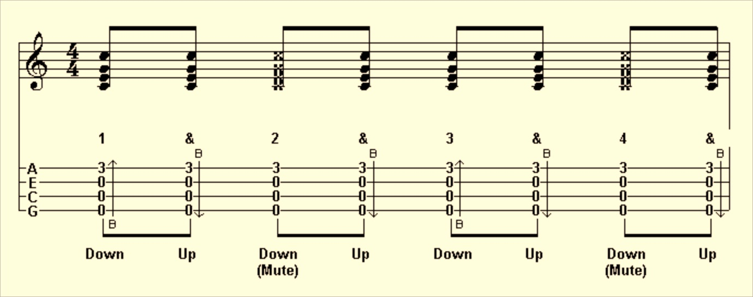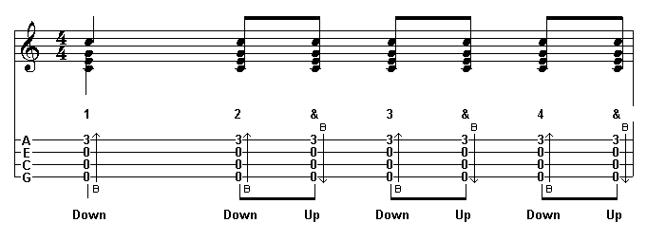

D-D-D-DU DUxUxUxU

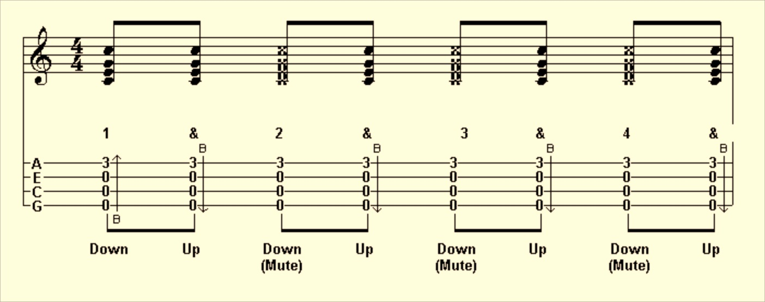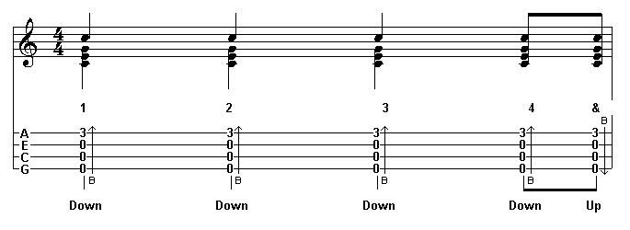

DUDUDUD- D-xU-UxU

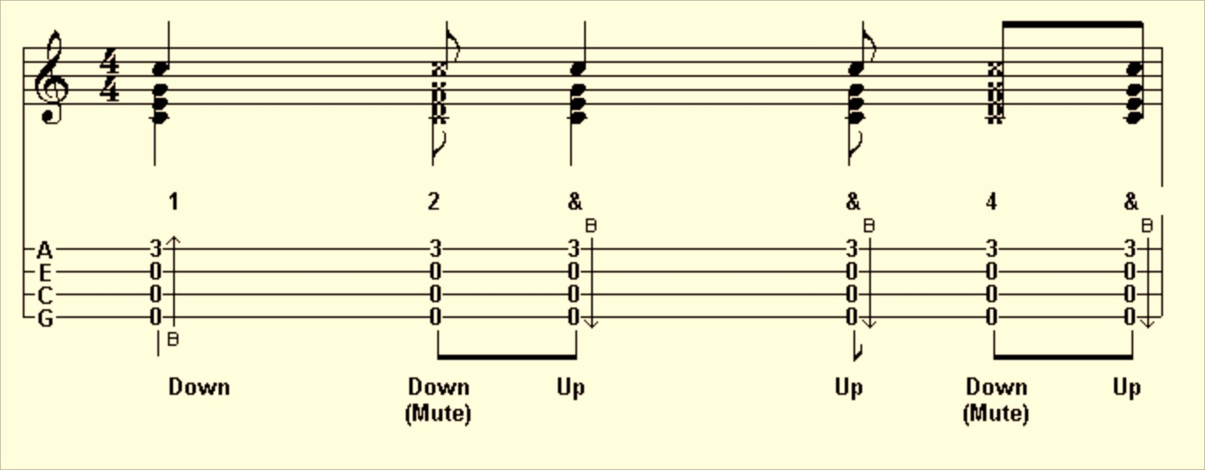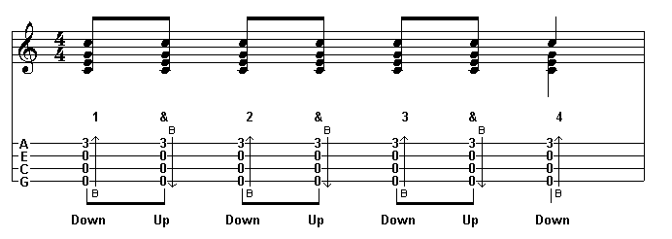

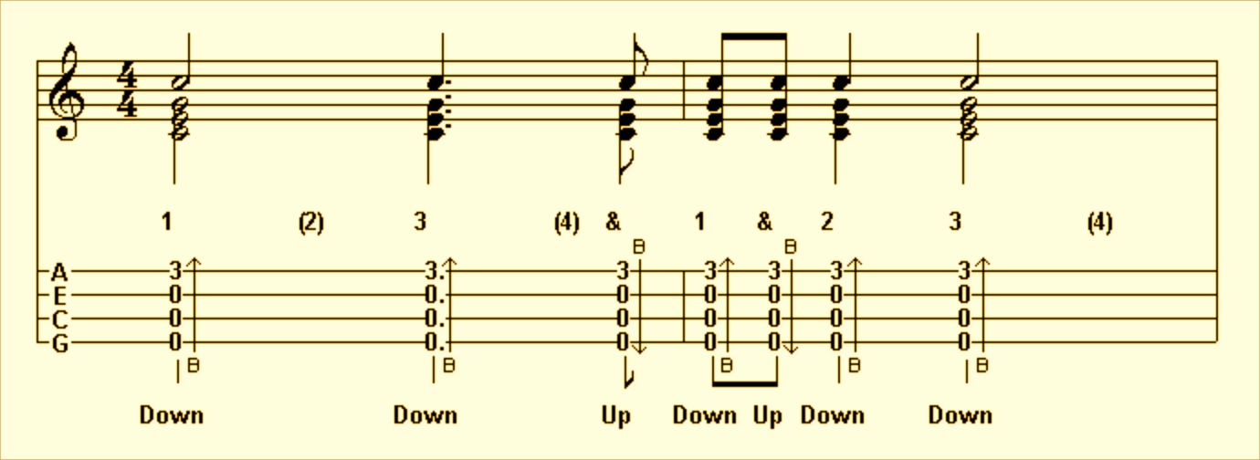D---D--UDUD- S. Madeline: D-DU-UDU-UDU-UD-

Half-bar: DUxU

D-DU

Emphasis: duDUduDU

DUxUDUxU

Reggae: -D-D-D-D

3/4: D-DUD-

D-DUDU